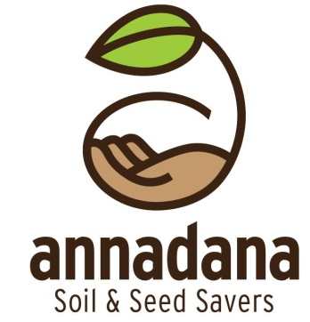
Publications Order Form
sl.no | Technical Publications | Format CD | 2015  ₹ | International  ₹ | Publications (color) ₹ | Select number of copies
1 | Seed sowing: Germination & Plant Techniques | PPT | 500 | 1500
2 |  | PPT | 800 | 2000
  Soil Fertility Management Techniques
3 | Auro Green Manuring Technique |  | 500 | 1500 | 1500
4 | Preparation of Raised Beds |  | 500 | 1000 | 1000
6 | Seed Saving Guide for Organic vegetables | PPT | 800 | 2000 | 2000
7 | Bio-plant Extract Preparation Techniques | PPT | 500 | 1200
9 | Annadana's 10 Best Practices |  | 800 | 1500 | 1500
10 | Disease Mangement | PPT | 500 | 1500
11 | Best Cultvation Practice For Cabbage Seed to Seed | PPT | 400 | 1500
12 | Best Cultvation Practice For Carrot Seed to Seed | PPT | 400 | 1500
13 | Organic Groundnut Cultivation Techniques | PPT | 400 | 1500
14 | Organic Pearl Millet Cultivation Techniques | PPT | 400 | 1500
15 | Organic Finger Millet Cultivation Techniques | PPT | 400 | 1500
16 | Organic Rice Cultivation Practice | PPT | 400 | 1500
17 | Home gardeners Guide | PPT | 500 | 1500
 | Technical Publications & Films
18 | Compost & Composting Techniques | PPT & FILM | 1000 | 2500
19 | Organic Growth Promoters Preparation Techniques | PPT & FILM | 1000 | 2500
 | Films
20 | Seed Saving For Peppers | Film | 800 | 2000
21 | Seed Saving For Tomato | Film | 800 | 2000
22 | Seed Saving For Brinjal | Film | 800 | 2000
23 | Seed Saving For Beans | Film | 800 | 2000
24 | Seed Saving For Corn | Film | 800 | 2000
25 | Seed Saving For Amaranth | Film | 800 | 2000
26 | Seed Saving For Lettuce | Film | 800 | 2000
27 | Seed Saving For Cucurbits | Film | 800 | 2000
28 | Seed Saving For Ladies Finger | Film | 800 | 2000
29 | Green Manure | Film | 800 | 2000
30 | Organic Rice Cultivation | Film | 800 | 2000
31 | Natural Method of pest Control | Film | 800 | 2000

For Online Dispatch:
- Kindly select publications and films of your choice and email your address/contact numbers to info@annadana-india.org. You will receive within 3 working days in India upon receipt of payment.
- For International dispatches, handling and courier costs will vary according to destination and weight. Only Indian currency (`) is accepted.
- Courier/ handling charges within India - `.300 for a minimum of 2 CDs only. The amount will vary if a range of books/publications and films are selected based on weight and destination
- You can credit via Bank Transfer to our Account :
    - Beneficiary: Annadana Soil & Seed Savers Network
    - Bank : State Bank of India ; Branch: Jalahalli East, Bangalore, India
    - Type of Account: Savings Bank Account
    - Account No: 30235939314
    - IFSC Code: SBIN0000963
Contact Details
- E-mail: info@annadana-india.org
- Phone : +91 80 23254400 | Mobile : +91 8277661106

Registered Office :
Annadana Soil and Seed Savers Network
Ishana in Gopathi farms, Village Singapura, Post Vidyaranyapura,
Bangalore – 560097 Karnataka, India
Land: +91 80 23254400, Cell : +91 8277116606
www.annadana-india.org

